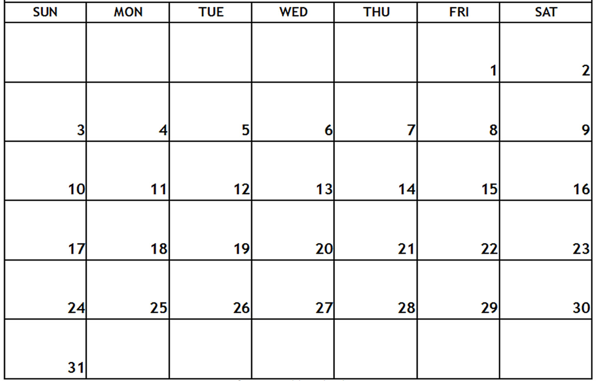

WORD AND BIBLE VERSE OF THE MONTH FAITHFULNESS Great is your
FAITHFULNESS Lamentations 3:23
Easter Party
MUSIC

THEMES: Pond Animals. Weather, Nutrition, St. Patrick’s Day
COLORS: Green, Blue SHAPE: Clover. Oval LETTERS: V, W, X NUMBERS: Review
MUSIC
CHAPEL
CHAPEL
CHAPEL
CHAPEL
MUSIC
MUSIC

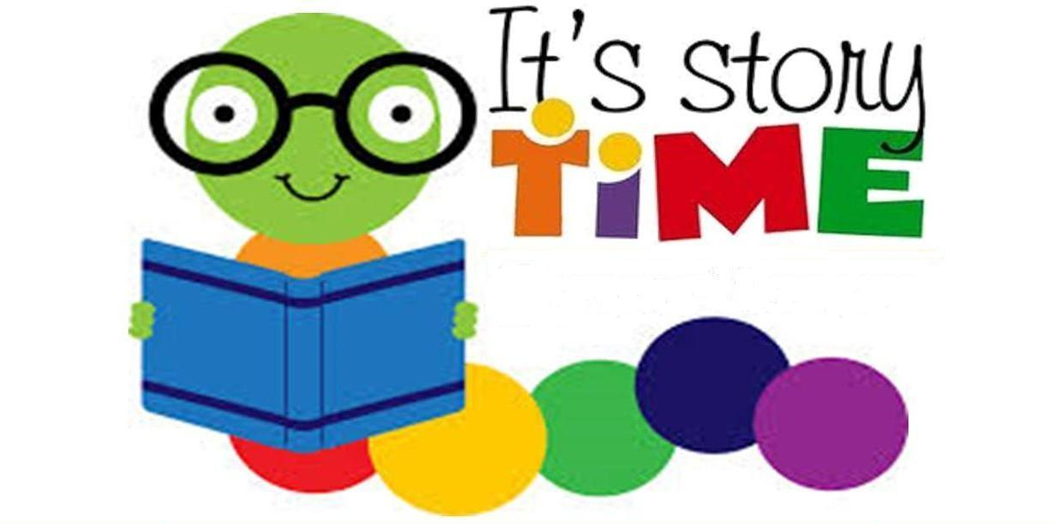
LIBRARY VISIT

