
CHAPEL

CHAPEL

CHAPEL

CHAPEL

MUSIC

MUSIC

MUSIC

MUSIC

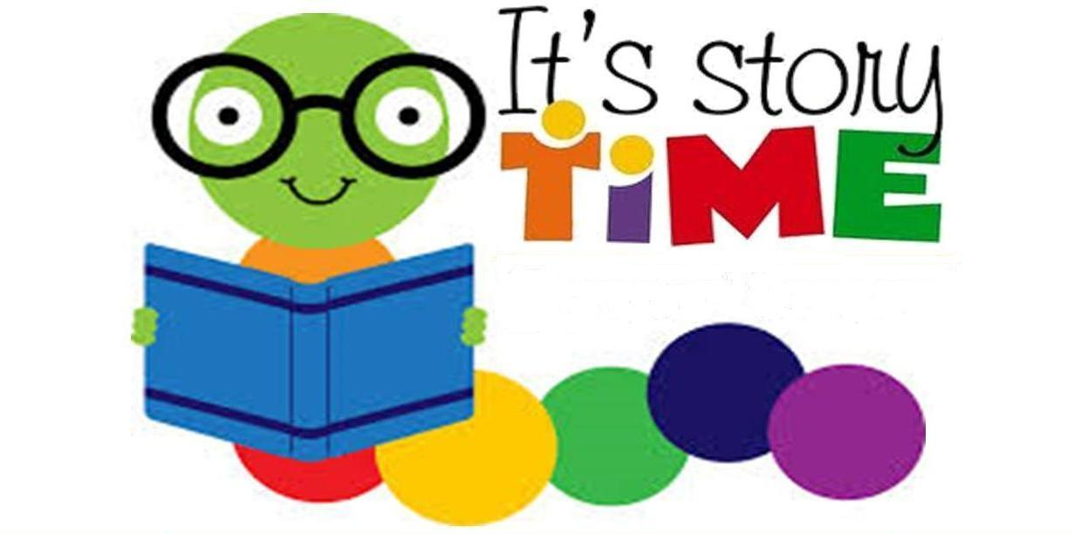
LIBRARY VISIT
Registration for Fall Opens

WORD AND BIBLE VERSE OF THE MONTH
LOVE one another.
1 John 3:23

THEMES: Dental Health, Be My Valentine, Ground Hog Day, Zoo Animals
COLORS: Pink and Purple SHAPE: Heart LETTERS: K, A, M, N NUMBERS: 10

NO SCHOOL
Valentine’s Day Party
Dentist Visit

