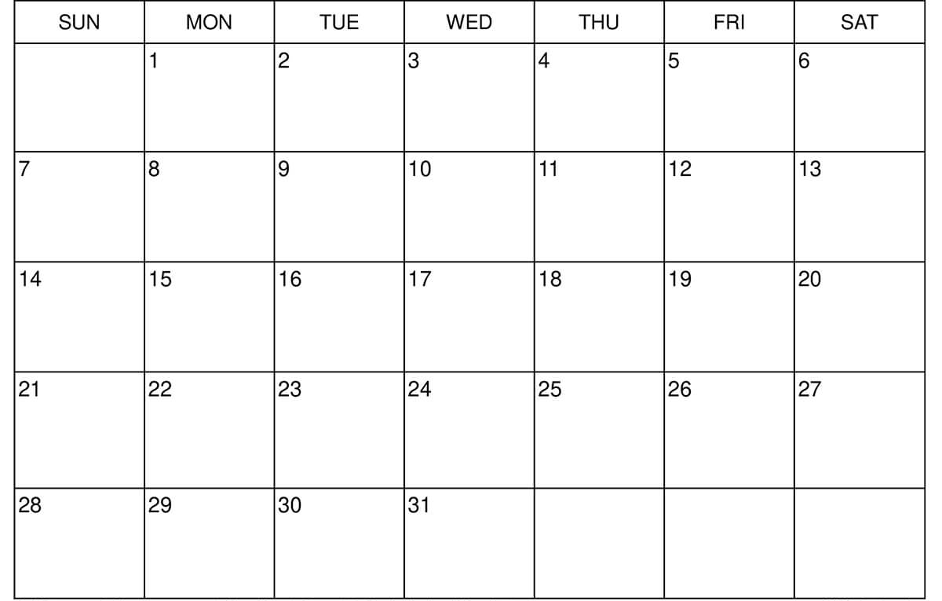
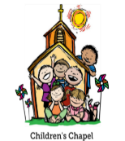
Library Visit
THEMES: Dr. King, Winter, Snowy Day, Winter Animals COLORS: White and Black SHAPE: Circle, Oval LETTERS: D, P, B, R NUMBERS: 8, 9
KINDNESS: BE KIND TO ONE ANOTHER EPH. 4:32

TEACHER WORKDAY
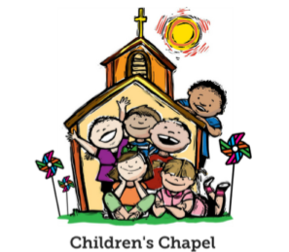CHAPEL
CHAPEL
CHAPEL
NO SCHOOL
MLK,JR DAY
TEACHER WORKDAY
MUSIC
MUSIC
MUSIC
MUSIC
EXOTIC ANIMAL ENCOUNTER VISIT

SCHOOL RESUMES


JANUARY

