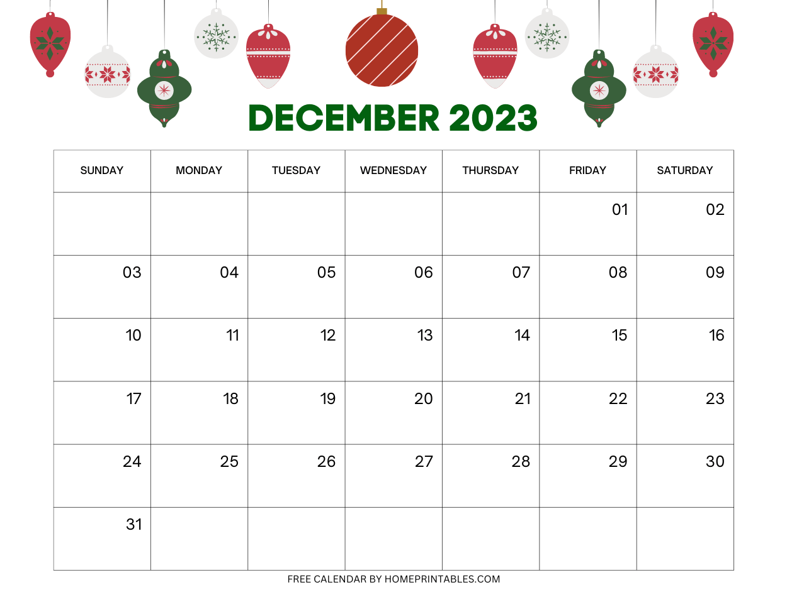
NO SCHOOL
CHRISTMAS BREAK
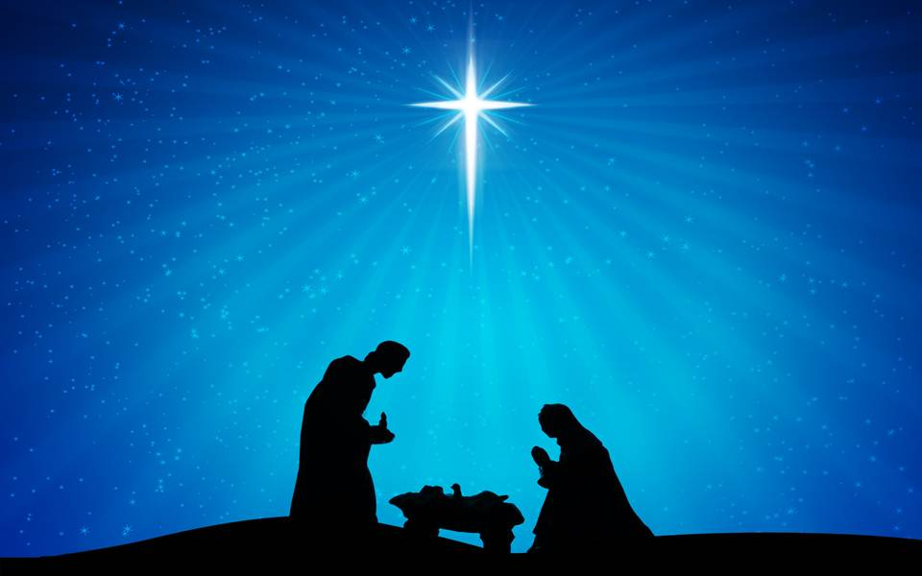
TEACHER WORKDAY
SCHOOL RESUMES
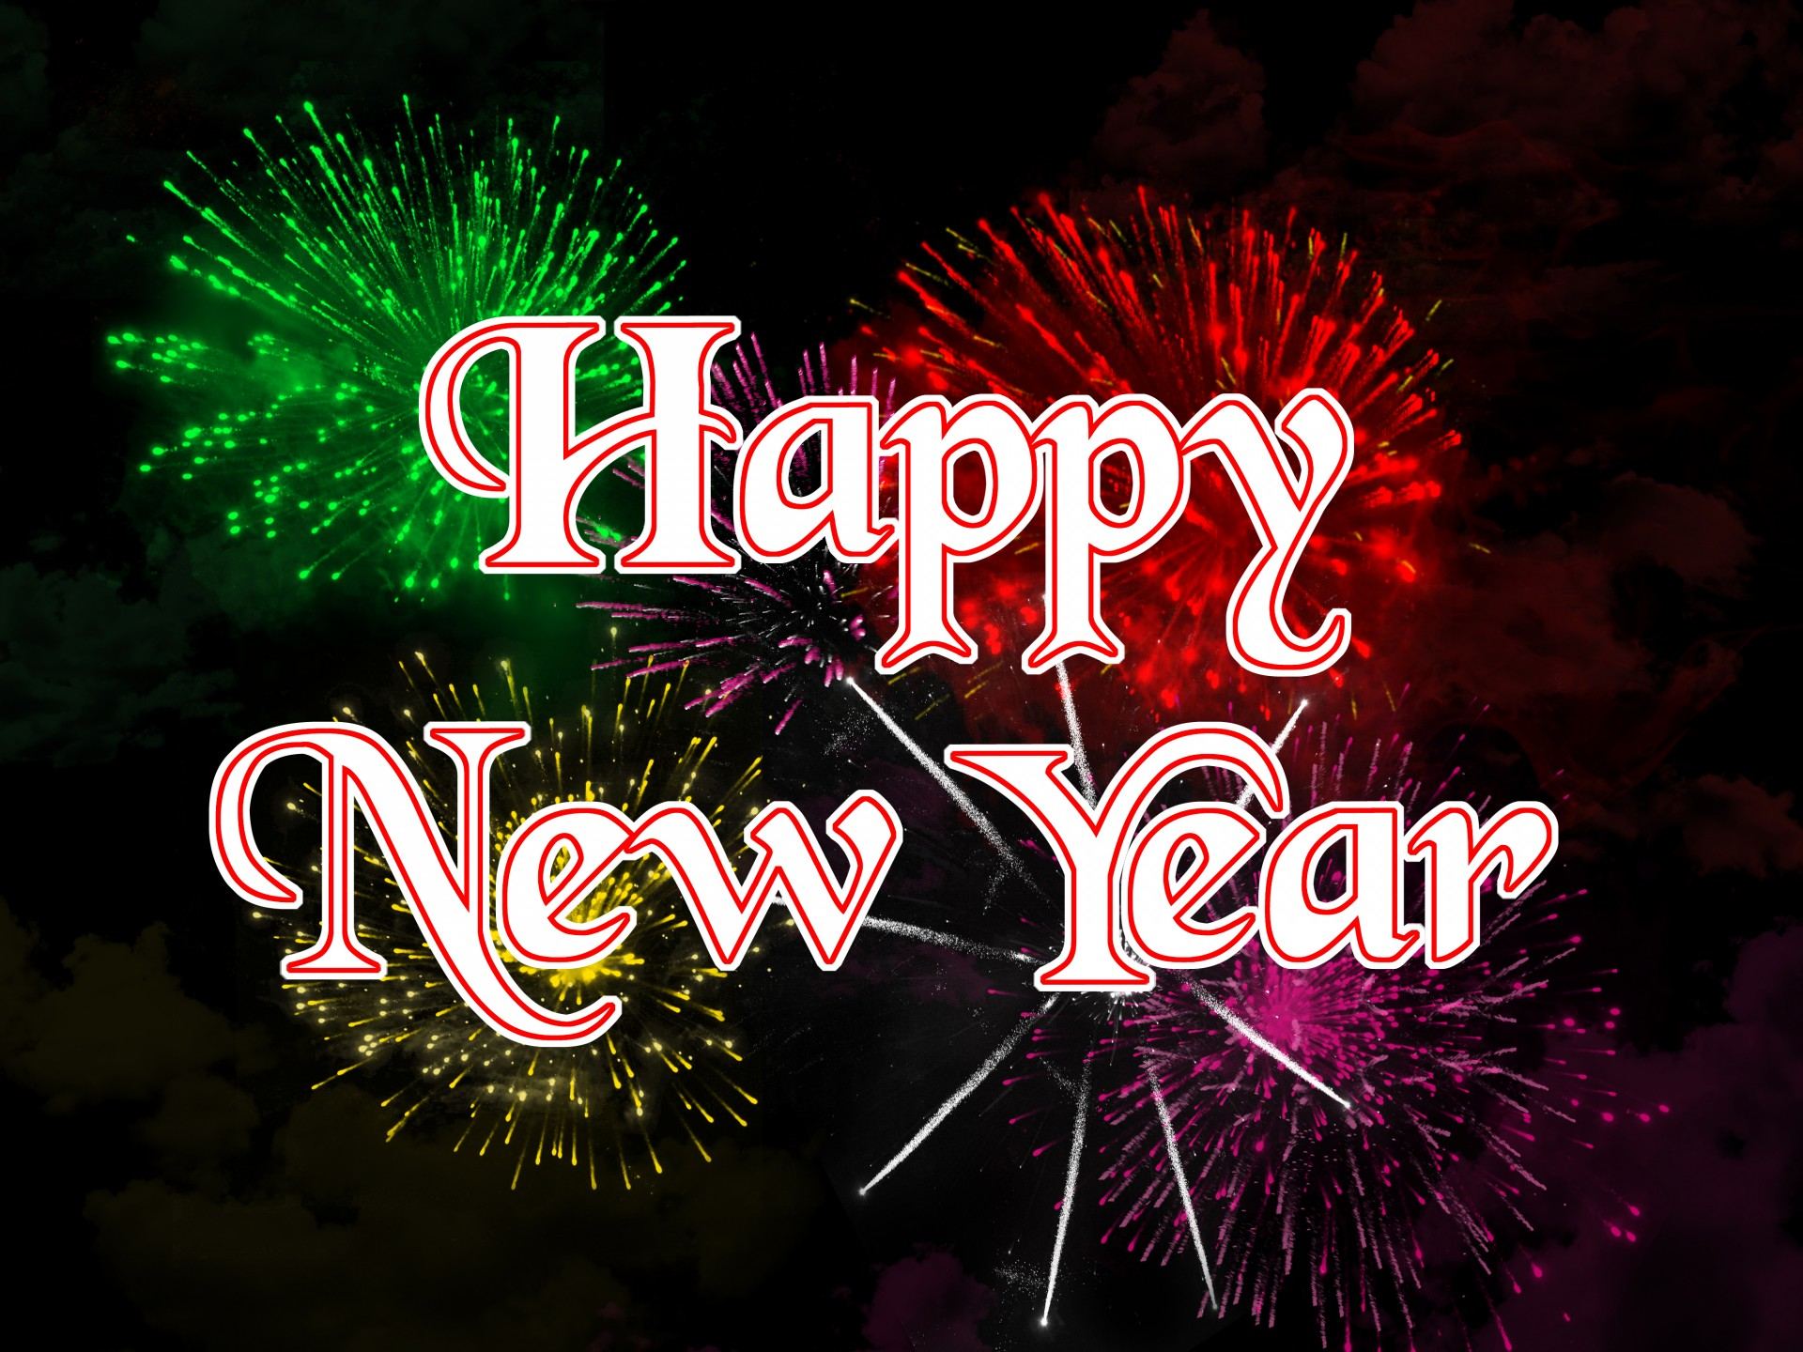
4
3
2
1
10:00AM CHRISTMAS CONCERT
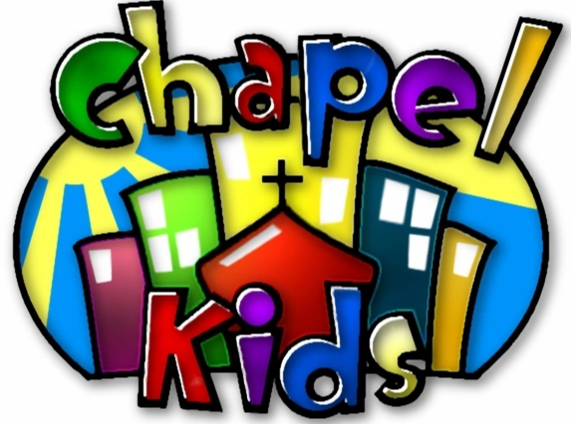
MUSIC 
MUSIC
BIBLE VERSE OF THE MONTH
FOR UNTO US A CHILD IS BORN
THEMES: CHRISTmas, Jesus’ Birthday
COLORS: Red, Green
SHAPE: Star LETTERS: S, J NUMBERS: 6, 7
.
Isaiah 9:6

PJ & PIZZA PARTY

