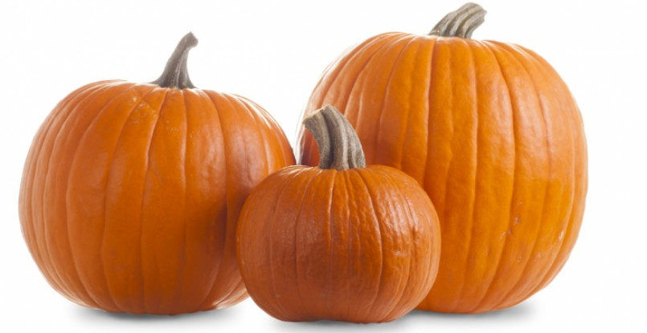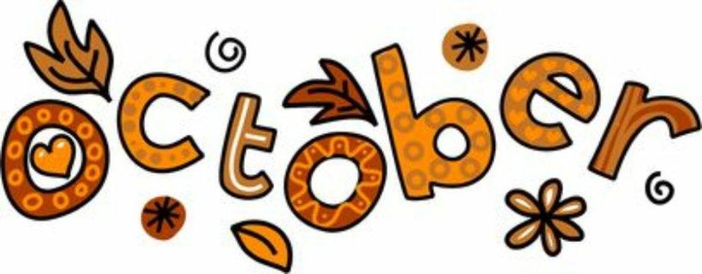
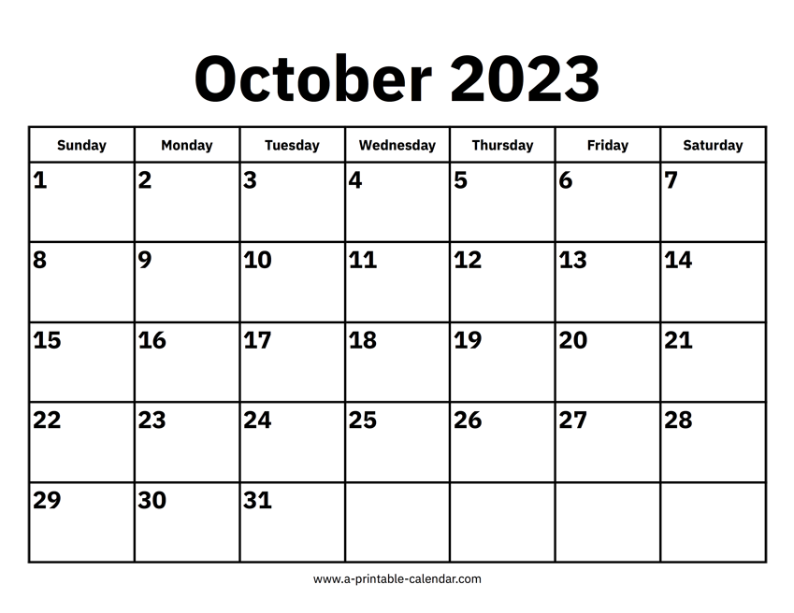
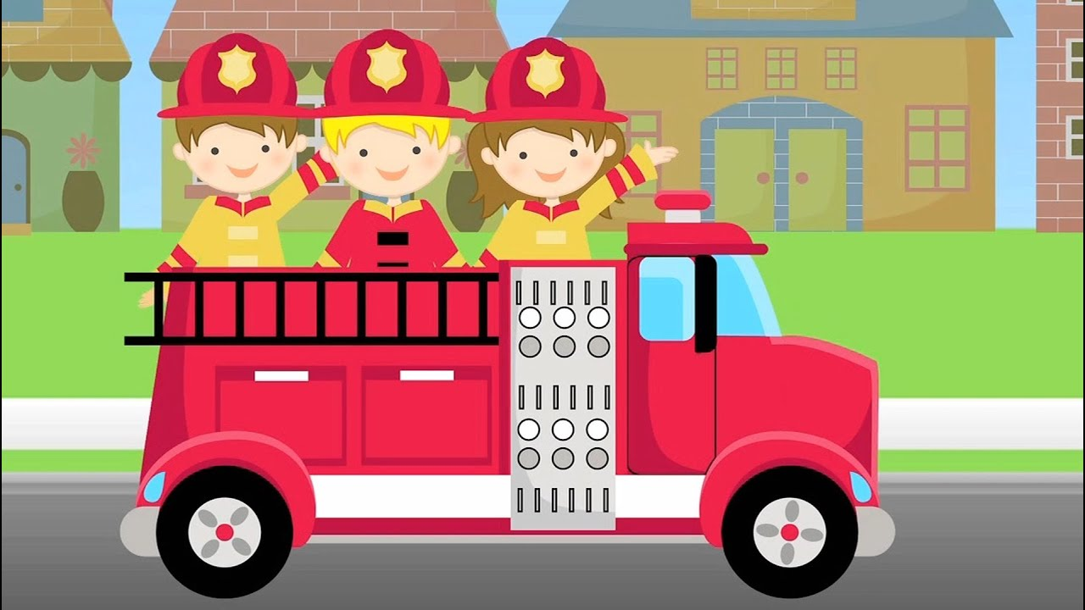FIRE TRUCK VISIT
10 AM PARKING LOT
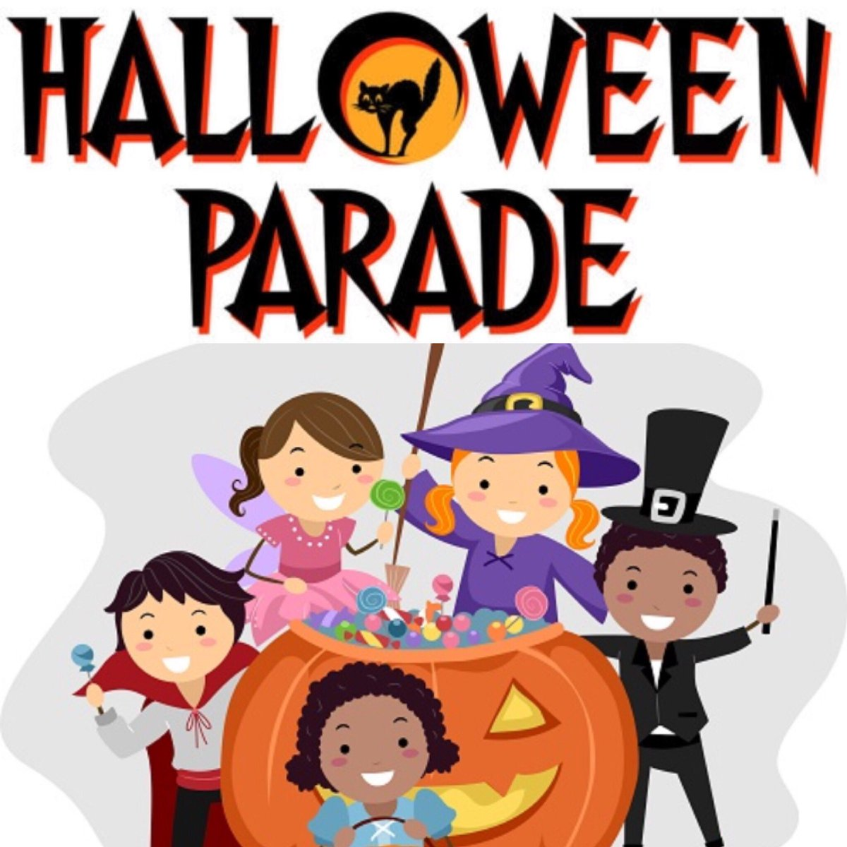
THEMES: Autumn, Pumpkins, Fire Safety, Night Creatures
Letters T, I, U, C Numbers 2,3
Joy-Psalm 95:1a Come, let us sing for JOY to the Lord

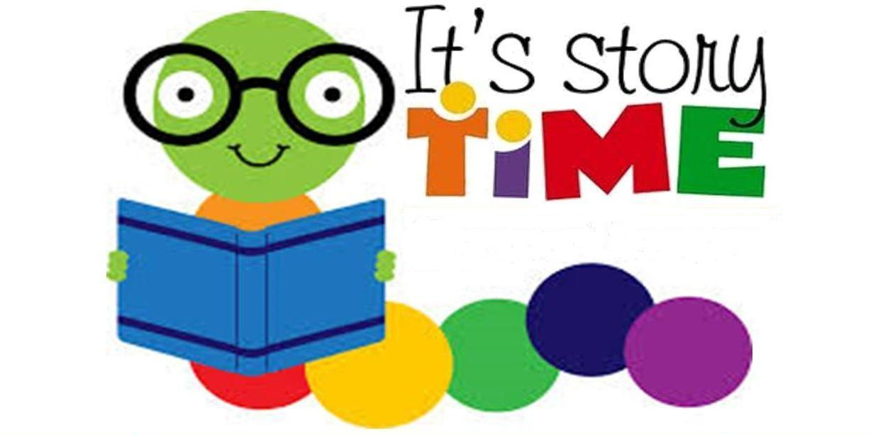Library Visit
MUSIC 
MUSIC
MUSIC
