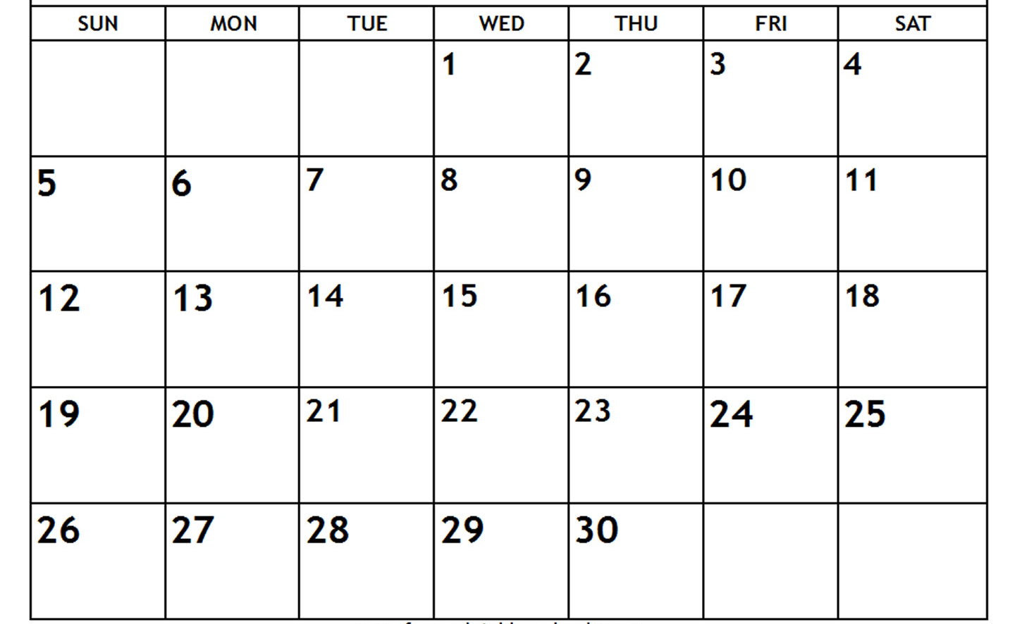
THEMES: Thanksgiving, Pilgrims & Indians
COLORS: Brown, Black SHAPE: Rectangle
LETTERS: O, Q, G NUMBERS: 4, 5
Give THANKS to the Lord for He is good.
Psalm 106:1

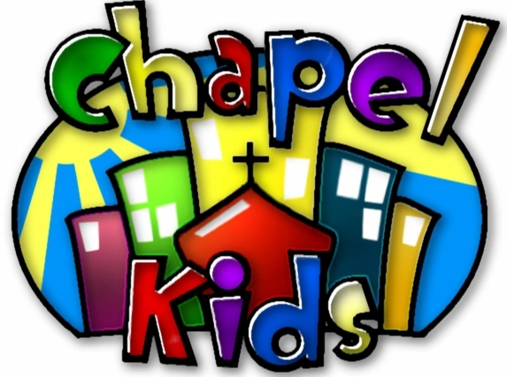


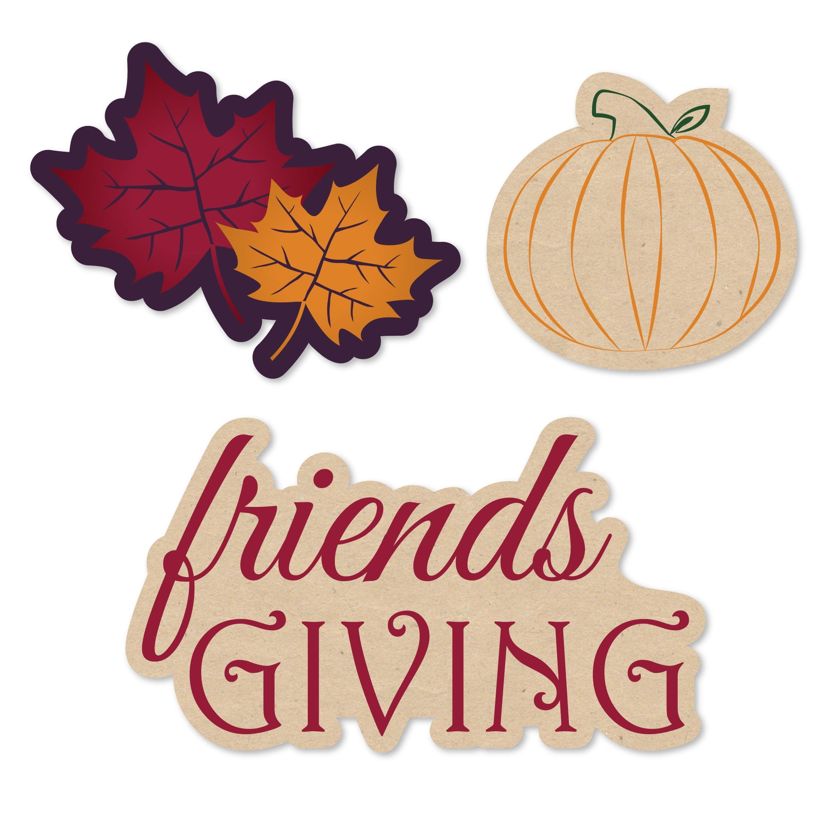

NO SCHOOL
VETERAN’S DAY
NO SCHOOL
ELECTION DAY
NO SCHOOL
TEACHER WORKDAY
NO SCHOOL
THANKSGIVING BREAK
NO SCHOOL
THANKSGIVING BREAK
